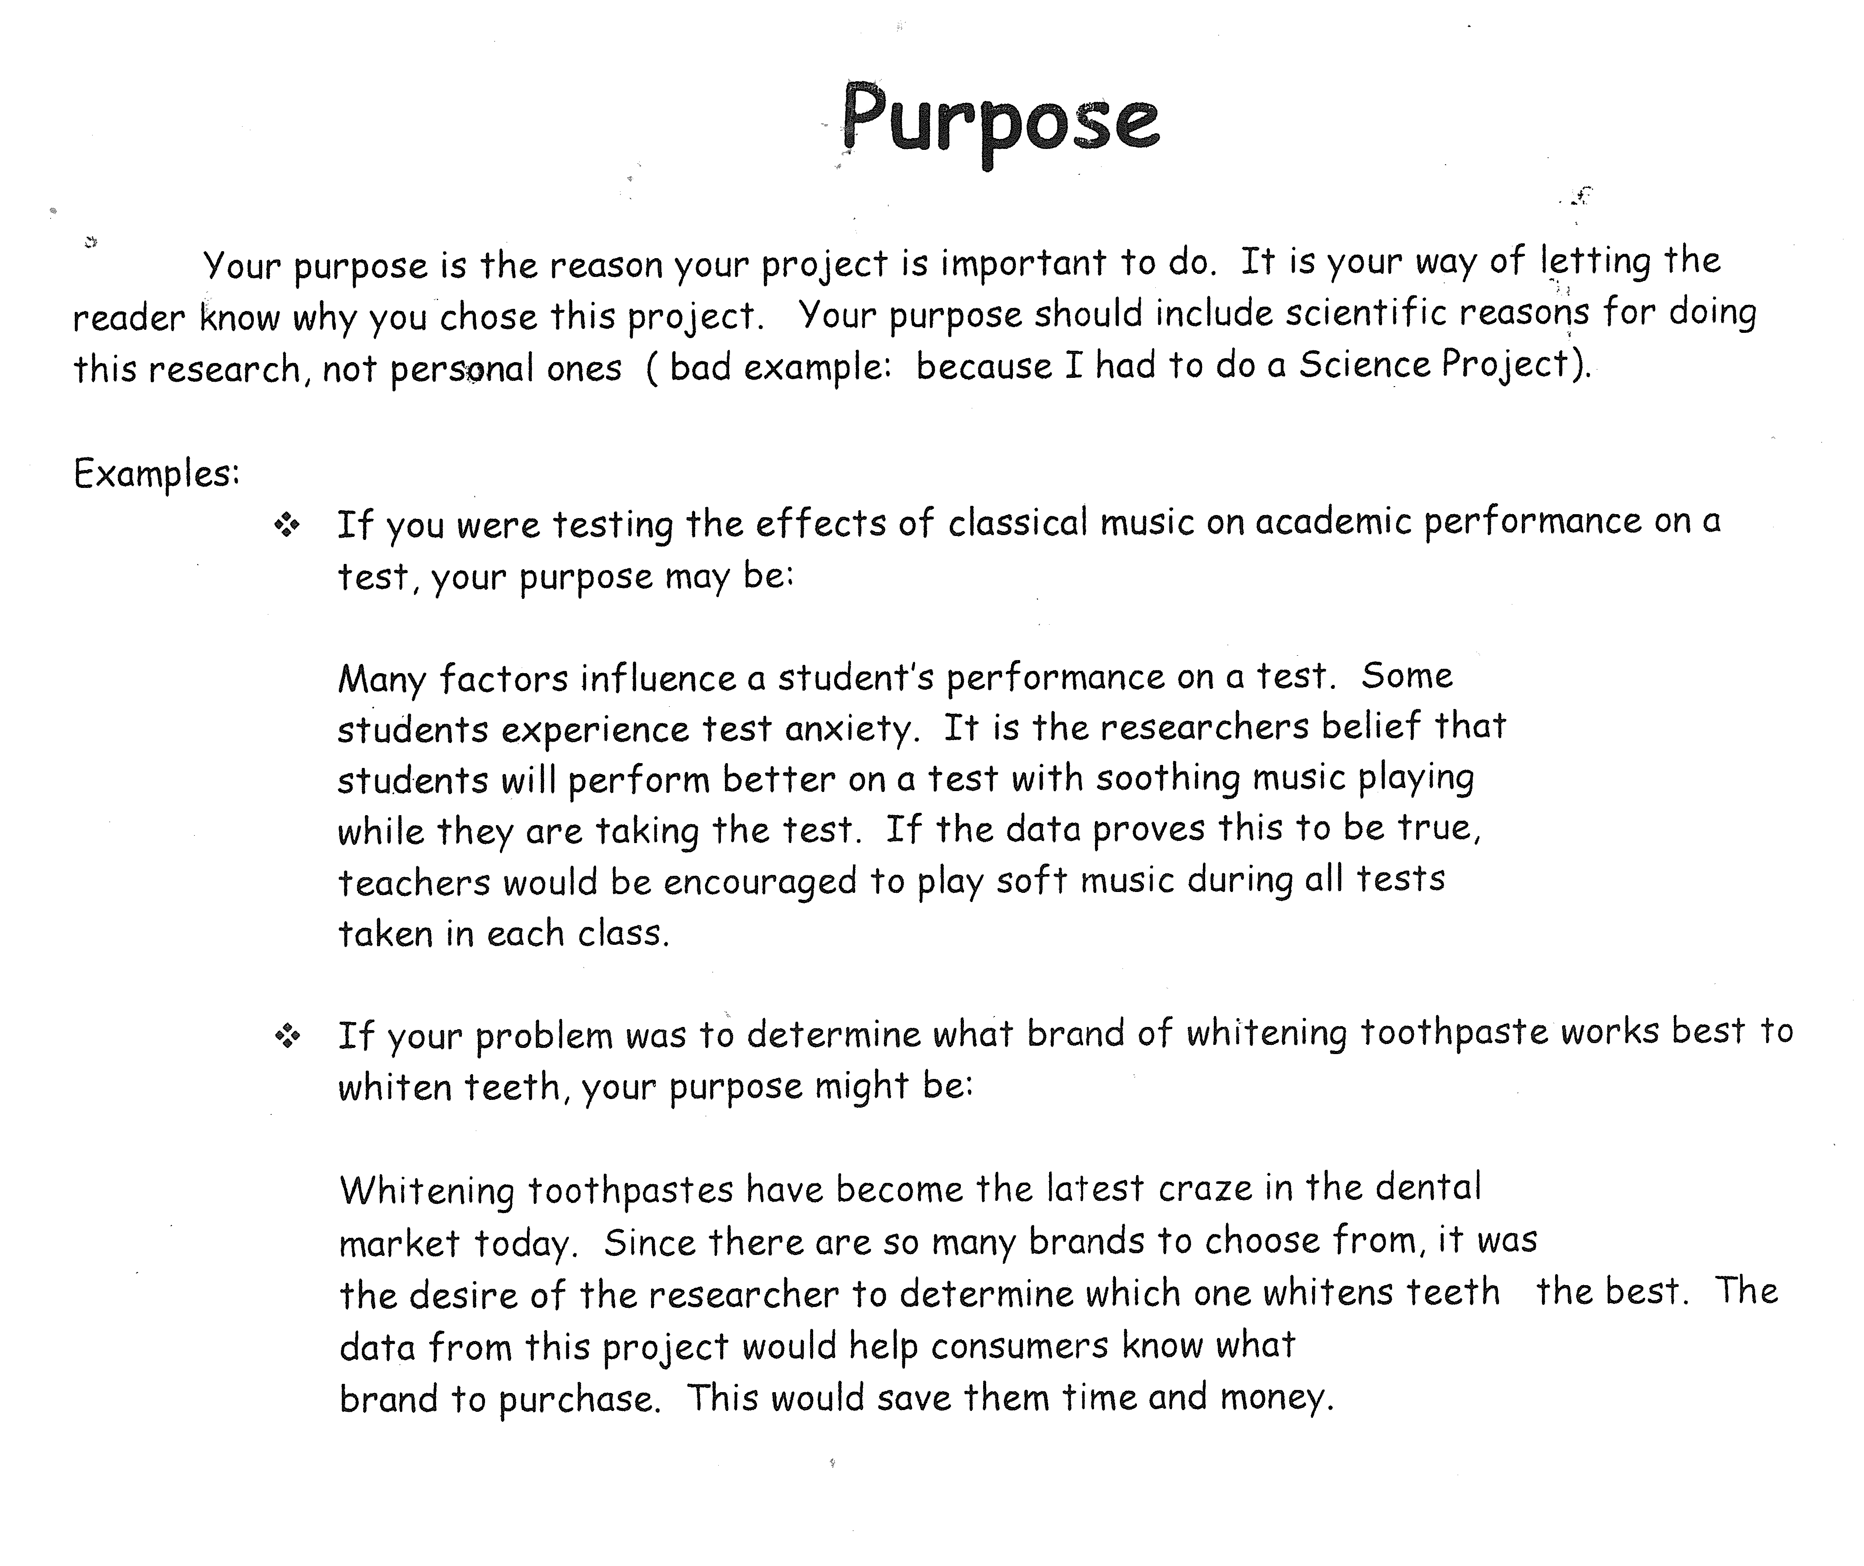
*Must be a short paragraph, at least 3 sentences.

*NOT written in first person, always refer to yourself as “the researcher.”

